Insert one

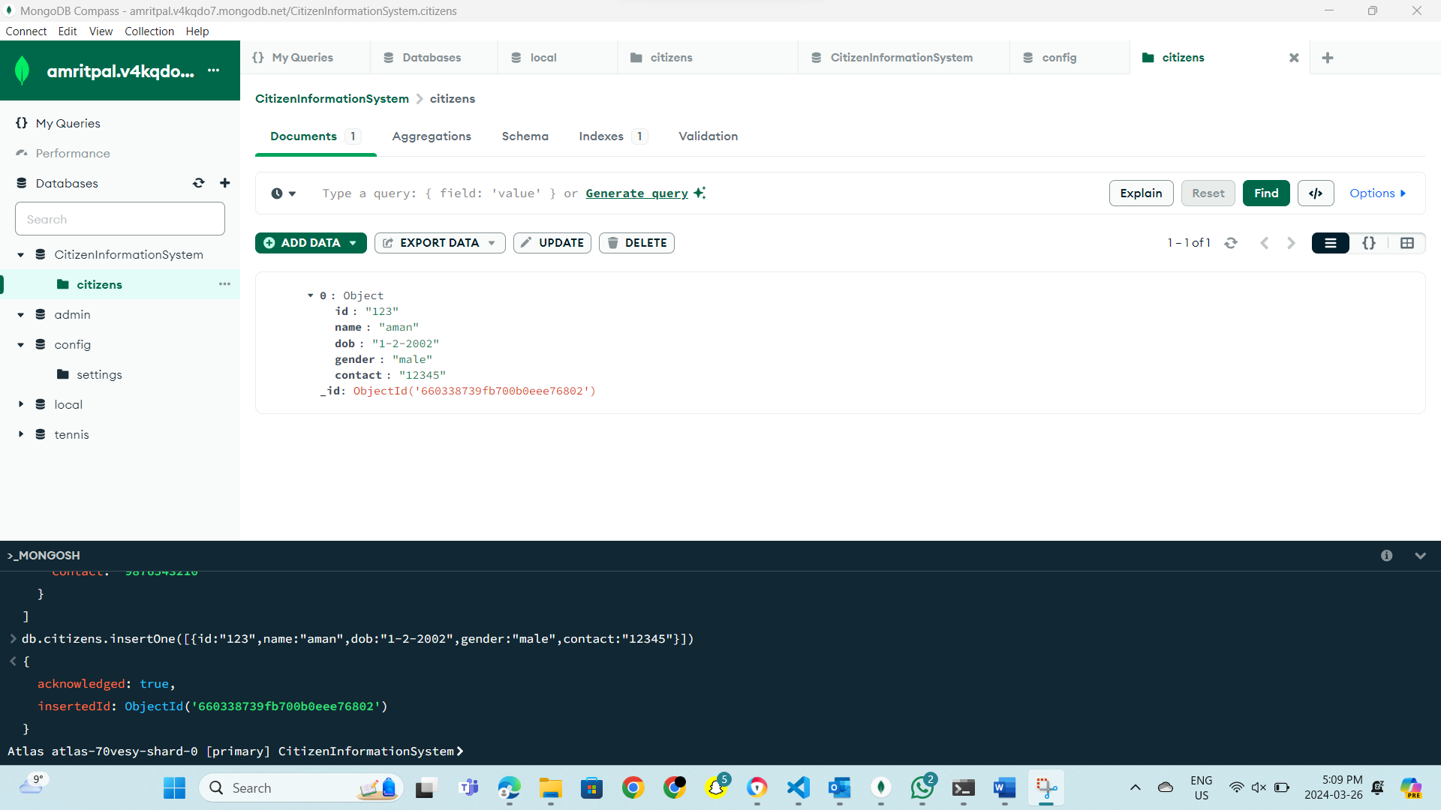

Figure 1: In this I have created the database according to my project and I have given the database name to it that is: - Citizeninformationsystem, furthermore I created a collection named citizens . Moreover, I inserted one document using insert One.

Figure 2: - I have used insertMany command and inserted 3 documents at a time.

Figure 3 : - the results of Insert Many

Figure 4 -: InsertMany

Figure 5 -: the results of Insert Many

Figure 6: - the results of Insert One

